**RESUME**

**MAYUR DHANAJI KATE** 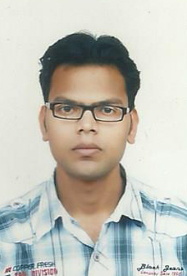

**C/83, SONAWANE CHAWL,**

**SURYA NAGAR, LBS MARG,**

**VIKHROLI (W),**

**MUMBAI -400 083, MAHARASHTRA.**

**MOB: +919702889525/9594994252**

**E-mail:** [**mayurkate33@gmail.com**](mailto:mayurkate33@gmail.com)

**PROFILE**

**Exceptional problem solver driven to succeed with strong interpersonal and negotiation skills and also capable of adopting and handling number of roles & responsibilities simultaneously.**

**OBJECTIVES**

* **To obtain a position in a company where I can maximize my management skills, quality assurance program, development and training program.**
* **Want to involve myself in a challenging environment offering scope for Growth & Development and an opportunity to apply my learning to effectively contribute towards the achievement of the organizational objective.**

**EDUCATIONAL DETAILS**

|  |  |  |  |
| --- | --- | --- | --- |
| **COURSE** | **YEAR OF COMPLETION** | **UNIVERSITY/COLLEGE** | **% OF MARKS OBTAINED** |
| **B.com** | **April- 2013** | **Mumbai University**  **Vikas college of commerce & arts** | **70.00%** |
| **HSC** | **February- 2010** | **Maharashtra State Board of secondary and higher secondary Education** | **68.17%** |
| **SSC** | **march- 2008** | **Maharashtra State Board** | **66.66%** |

**COMPUTER SKILLS**

**KNOWLEDGE IN MS-OFFICE (WORD/POWERPOINT) & INTERNET.**

**Personal Details:**

**Marital Status: Single**

**Languages Known: English, Hindi, and Marathi**

**Hobbies: Internet surfing, cricket.**

**Strengths: Confidence, Cool and Calm thinking.**

**Strong Determination, Highly Ambitious.**

**WORK EXPERIENCE :**

**Fresher**

**DECLARATION**

**I hereby declare that all the information given above is true to the best of my knowledge.**

**Place: Mumbai yours sincerely,**

**Date: 10/03/2014 Mayur Dhanaji Kate.**